TexturePacker User Guide

Table of Contents

Introduction 2

Getting Started 2

Download and install Adobe Photoshop 2

Download and install TexturePacker 2

Export Animation from Photoshop 2

1. Open the animation file in Photoshop 2

2. Go to **File** > **Export** > **Render Video** 3

3. A Render Video windows will pop up 4

Name 4

Select Folder 5

Create New Subfolder checkbox 5

Adobe Media Encoder or Photoshop Image Sequence? 6

File format 6

Other format options 6

Range 7

Render Options 7

4. Summary 7

Working with TexturePacker 8

1. Creating static assets 8

2. Creating dynamic assets 13

3. Summary 15

Creating Glyph assets aka. Graphic fonts for games (I will write this next time) 16

# Introduction

This guide is not made for everyone. I am not an expert in user guide so please, do not put your expectation high.

This guide is a step by step instruction how to export animation from Photoshop and put them into TexturePacker.

# Getting Started

## Download and install Adobe Photoshop

Get it at <https://www.adobe.com/ca>

## Download and install TexturePacker

Get it at <https://www.codeandweb.com/texturepacker>

# Export Animation from Photoshop

## Open the animation file in Photoshop

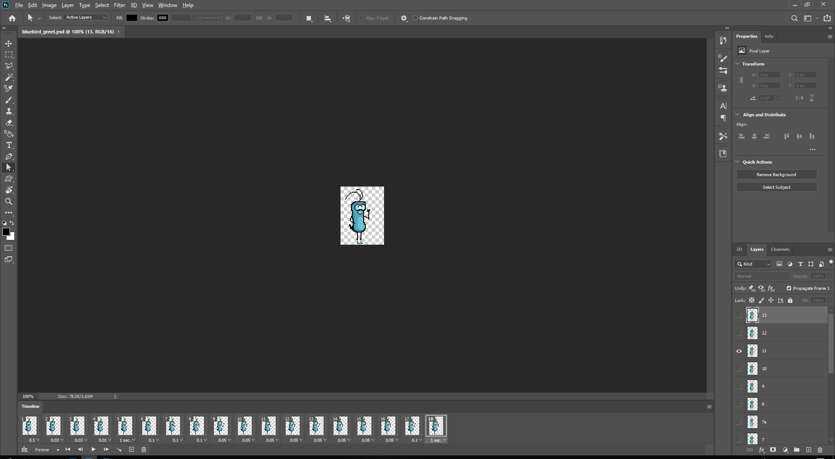

## Go to **File** > **Export** > **Render Video**

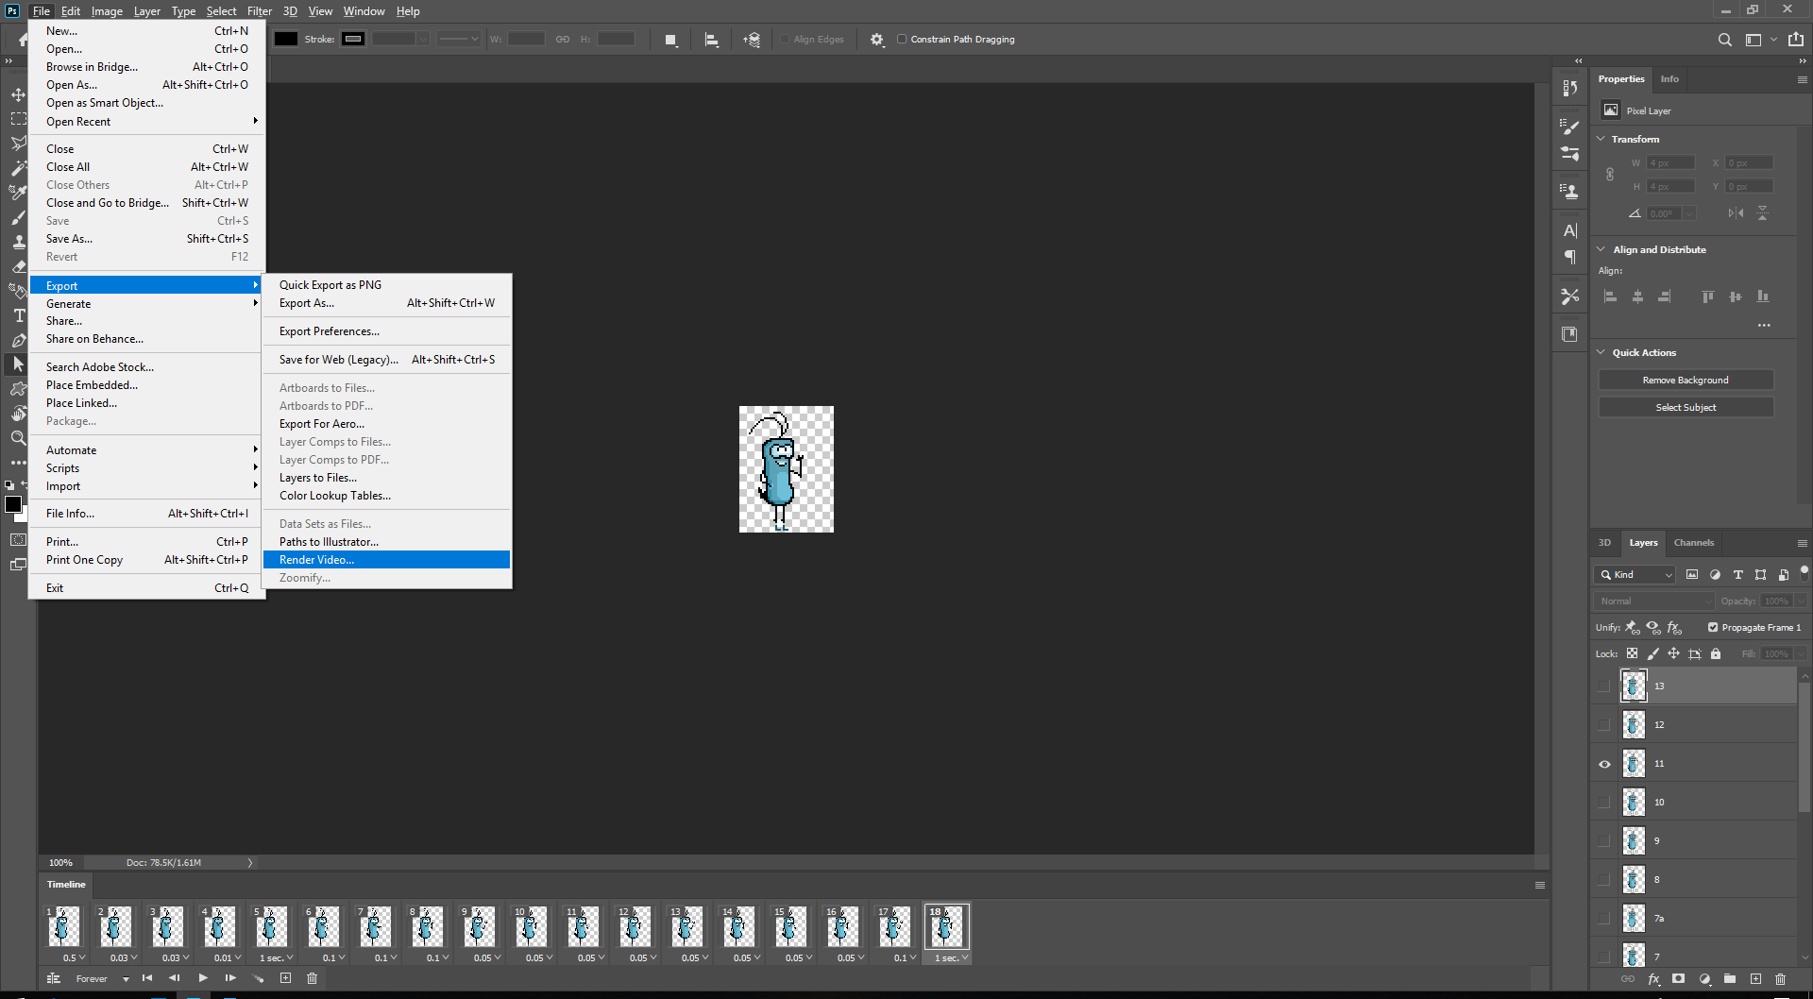

## A Render Video windows will pop up

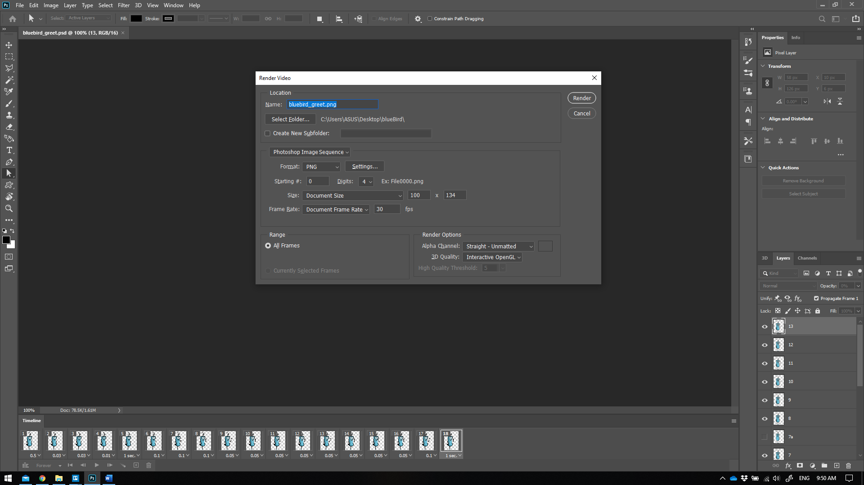

From top to bottom:

### Name

* The output name suffix of the exporting files if your animation had more than 1 frame.
* Look at the name I had in the example: *bluebird_greet.png*

“*bluebird*” is the name of the character.

“*greet*” is the action of the current animation. In our project, it is likely that one character would have multiple actions.

* If I left as it is, Photoshop will export it to multiple file look like this image below:

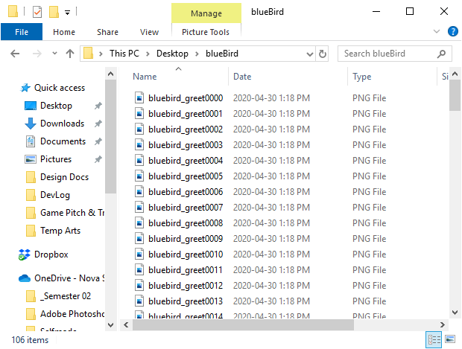

You can see that it put 4-digit number right next to the name. That is okay but not quite well organized.

I recommend you put an extra underscore next to the file name which looks like this:

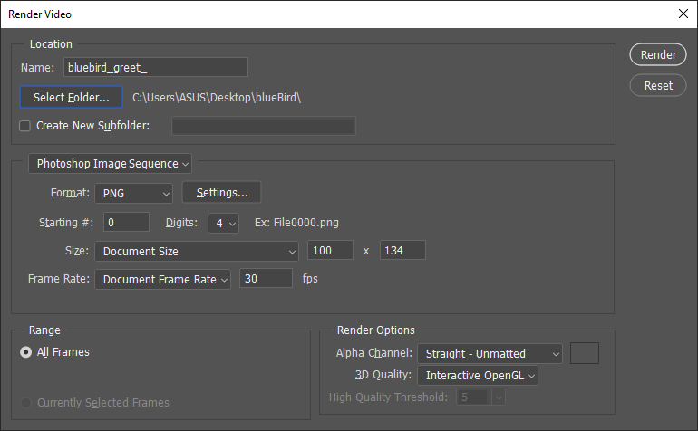

It would separate the name and the number, which is very easy to read and keep track.

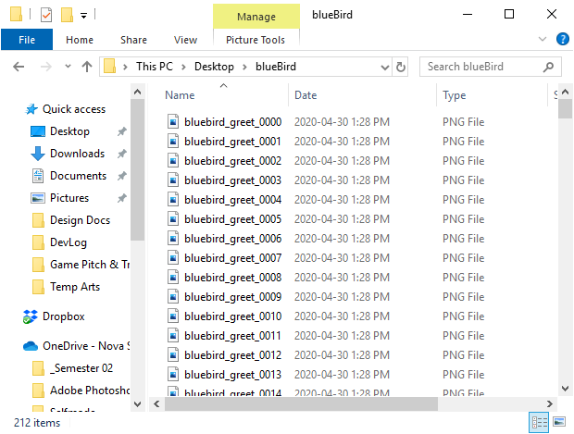

This looks better, don’t you agree?

### Select Folder

* This button allows you to change the location for exported files.
* I recommended you put all your exported animation in Resources folder, which where programmer would look for data implementation

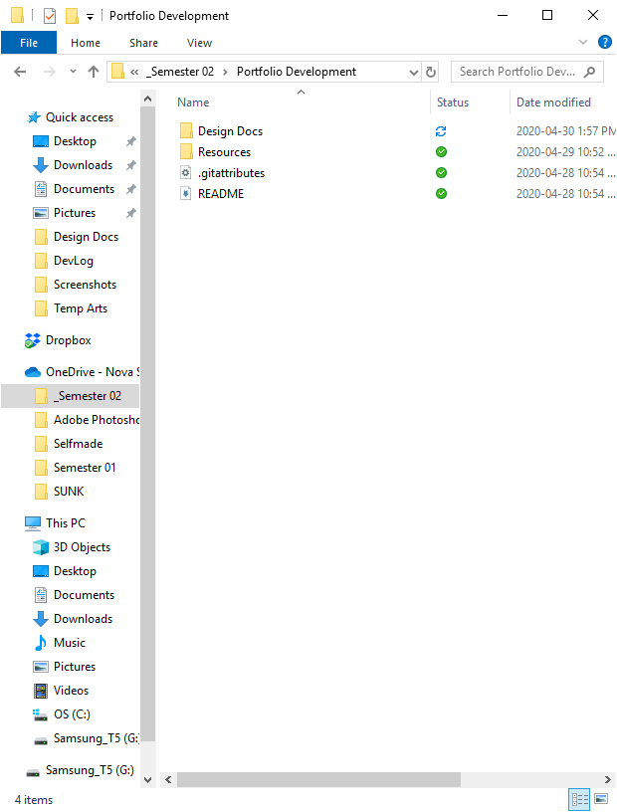

### Create New Subfolder checkbox

* This button allows you to create a new subfolder and put all the exported files onto it.
* I recommend you create separate subfolder for each animation of the same character. It is well organized and would not accidentally override your other animations during the process.
* Just simply check the checkbox and type in the name of the folder you want

### Adobe Media Encoder or Photoshop Image Sequence?

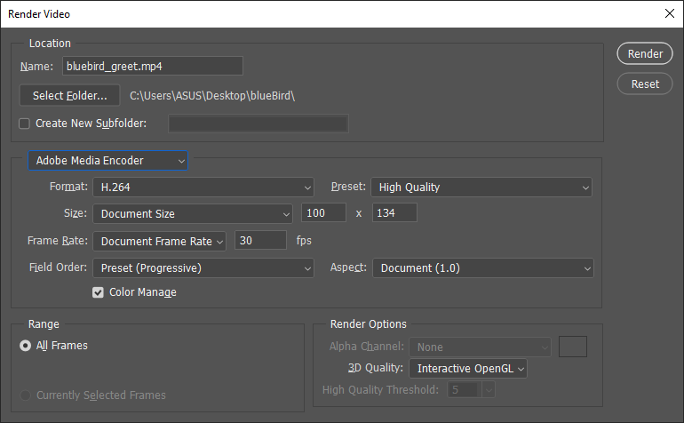

* The first time you opened the Render Video windows, Photoshop probably uses this encoding method by default. This is not what we are going to use.
* Click on it and select Photoshop Image Sequence

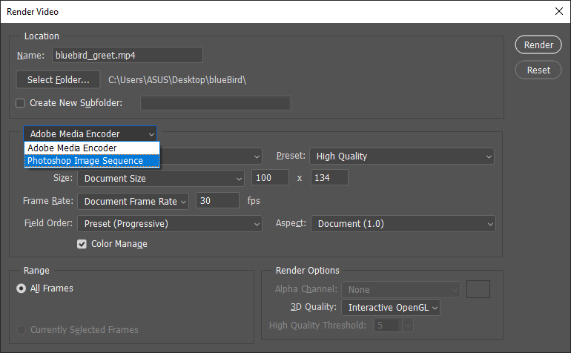

* You will see new settings for this encoding method. This is super important, please proceed carefully

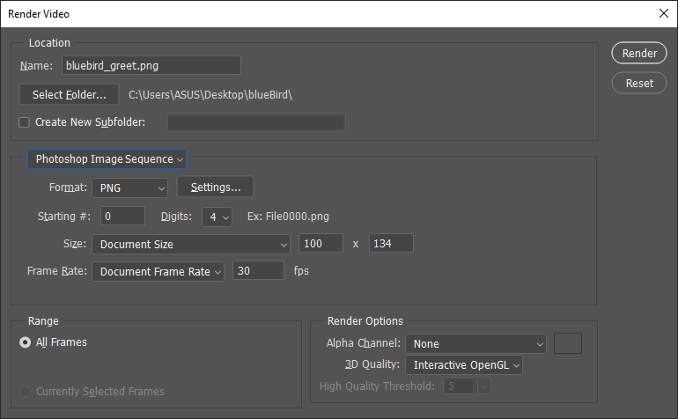

### File format

* Select PNG
* In the Settings button next to it, choose Large file size to keep the best image quality

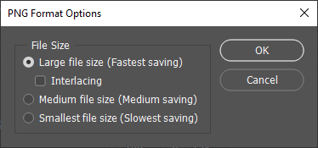

### Other format options

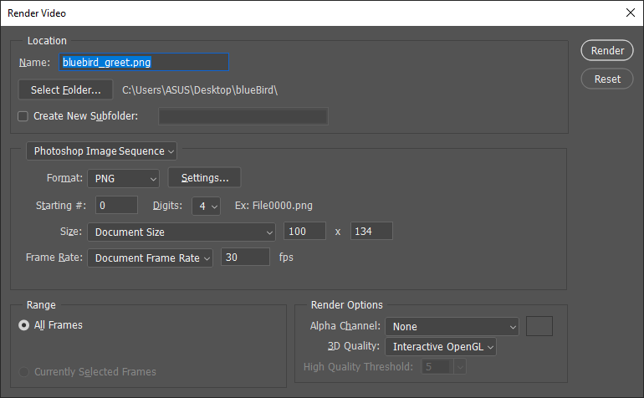

* Starting #: This affect the starting number in the naming prefix of the exported files. Just leave it be.
* Digits: As you have seen in the first demonstration above, the exported files have 4-digit number. If you were sure that your animation would never exceed 100 frames, you could change it down to 2-digit. I personally prefer 3-digit. It is your choice.
* Size: Just leave it be, it will use the dimensions of the document canvas.
* Frame Rate: Just leave it be, our game and most of other games out there are using 30 fps.

### Range

* Do not touch it.

### Render Options

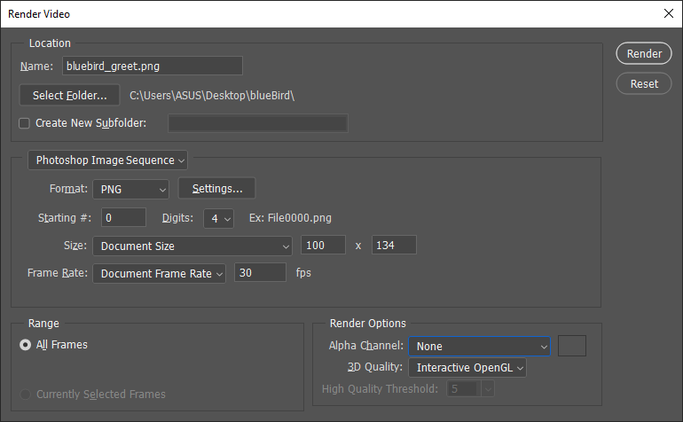

* Alpha Chanel: Default is None, change it to Straight – Unmatted. It would allow exported images have transparent background

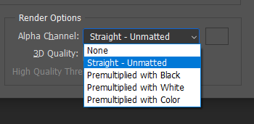

* 3D Quality: Just leave it be
* You can hit Render after this

## Summary

Things to remember before hitting **Render** button

1. Place an extra underscore at the end of the file name (if there was not any).
2. Export animation into Resources folder of the common working folders.
3. Use separate folder for each animation.
4. Make sure encoding method is Photoshop Image Sequence.
5. Format type is PNG with Large File Size for highest image quality.
6. Make sure the Alpha Chanel uses Straight – Unmatted for transparent background.

# Working with TexturePacker

## Creating static assets

Static assets are artwork that has no animation, like background images, buttons, banners, splash arts.

In this example, I’m going to use a splash image taken from <https://ansimuz.itch.io/cyberpunk-street-environment>

* Open TexturePacker

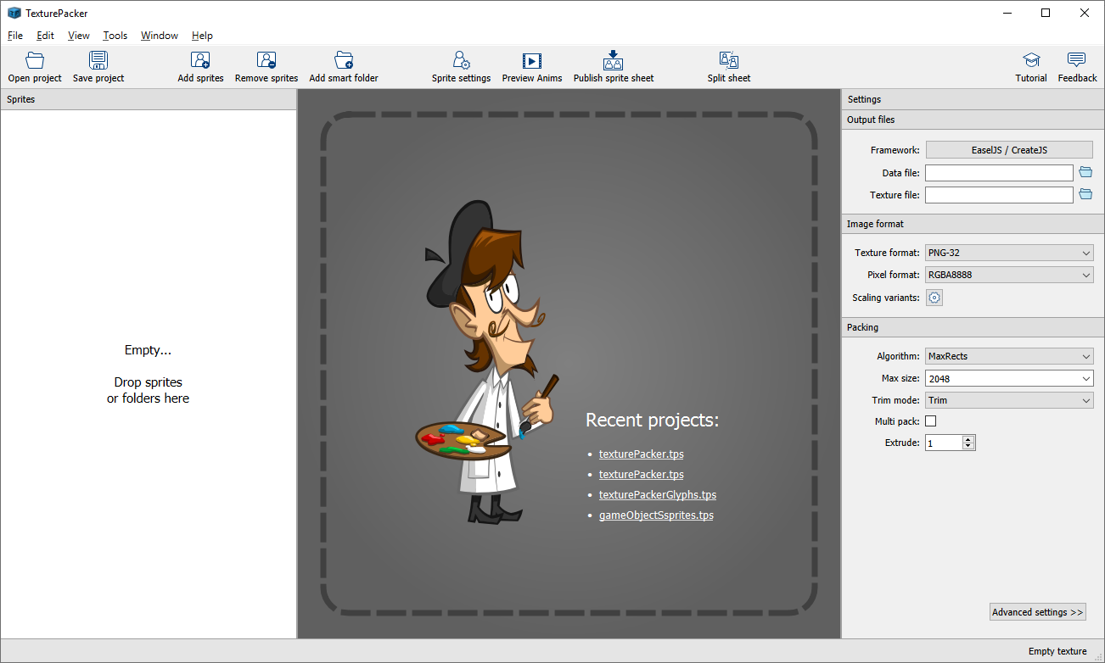

* Drag the image or image folder into TexturePacker

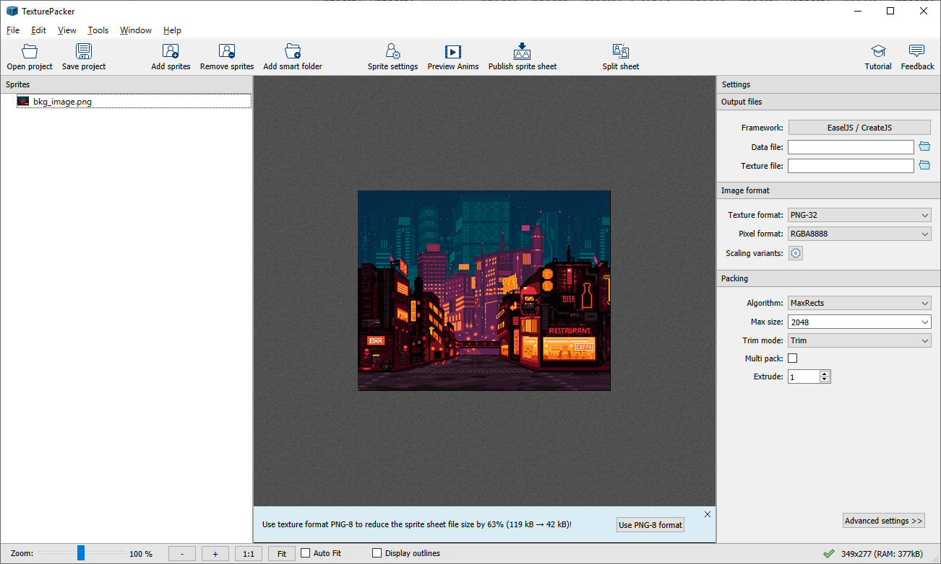

* Select the image and click on Sprite Settings to change it Pivot Point (very important)

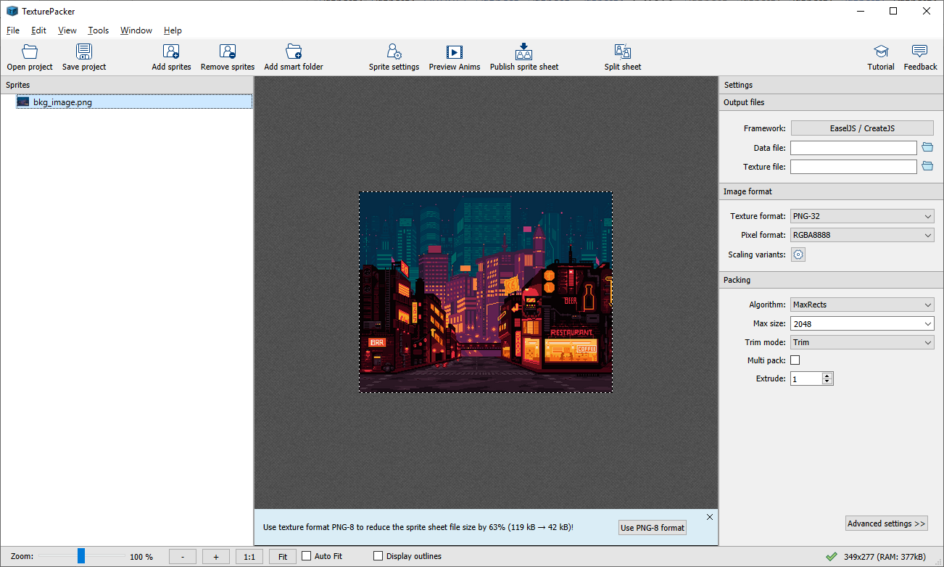

* By default, the pivot is at the center of the sprite. Change it to Top Left.

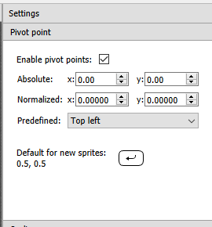

All the static assets’ pivot should be Top Left, unless defined somewhere else by programmer.

* Hit Back to sheet to make changes to other settings

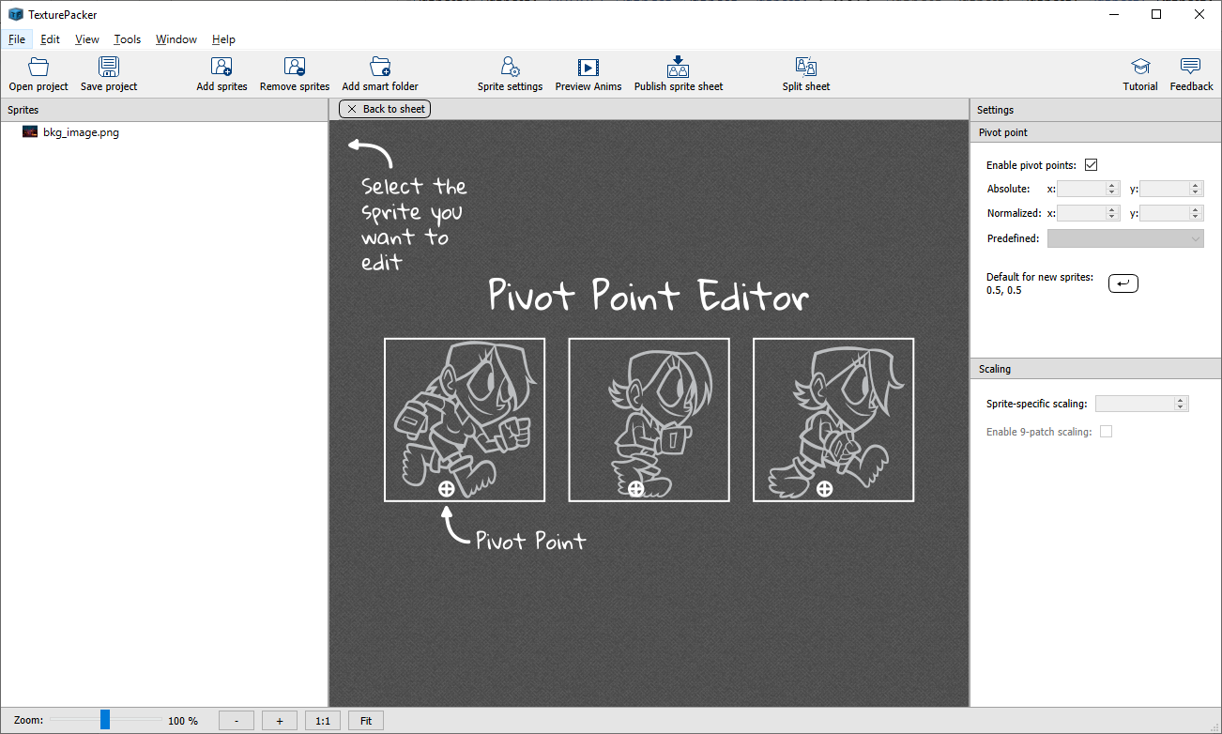

Now Look at the Settings Panel on the right side

* Change Framework to EaselJS / CreateJS
* Set the output data file path and file name. I would recommend you put it inside the Resources folder. Save as type JSON file. TexturePacker would also create a new image file for this JSON file.
* Other settings should like this image below

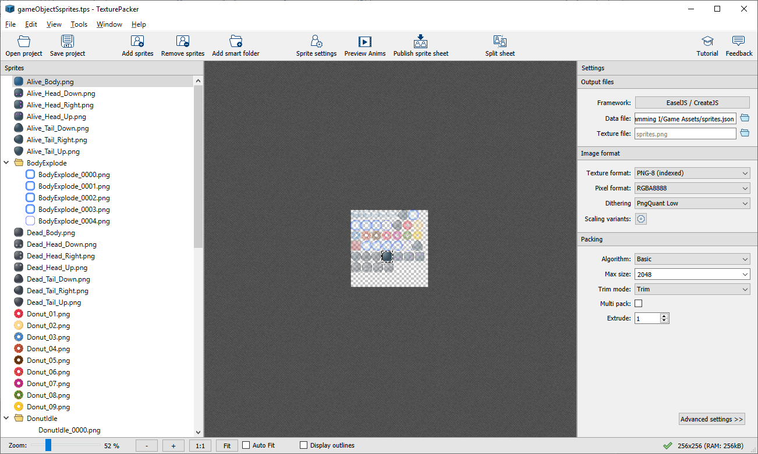

* Advanced settings should like these images below

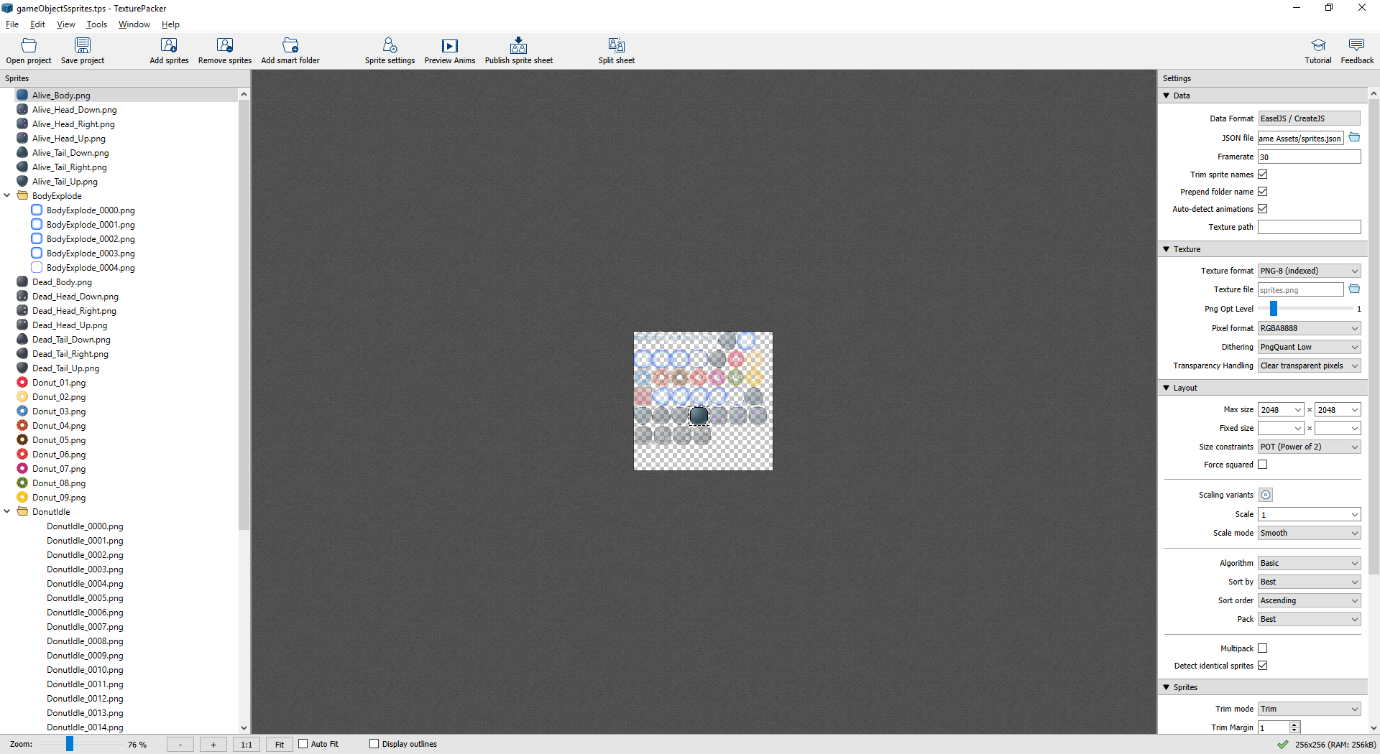

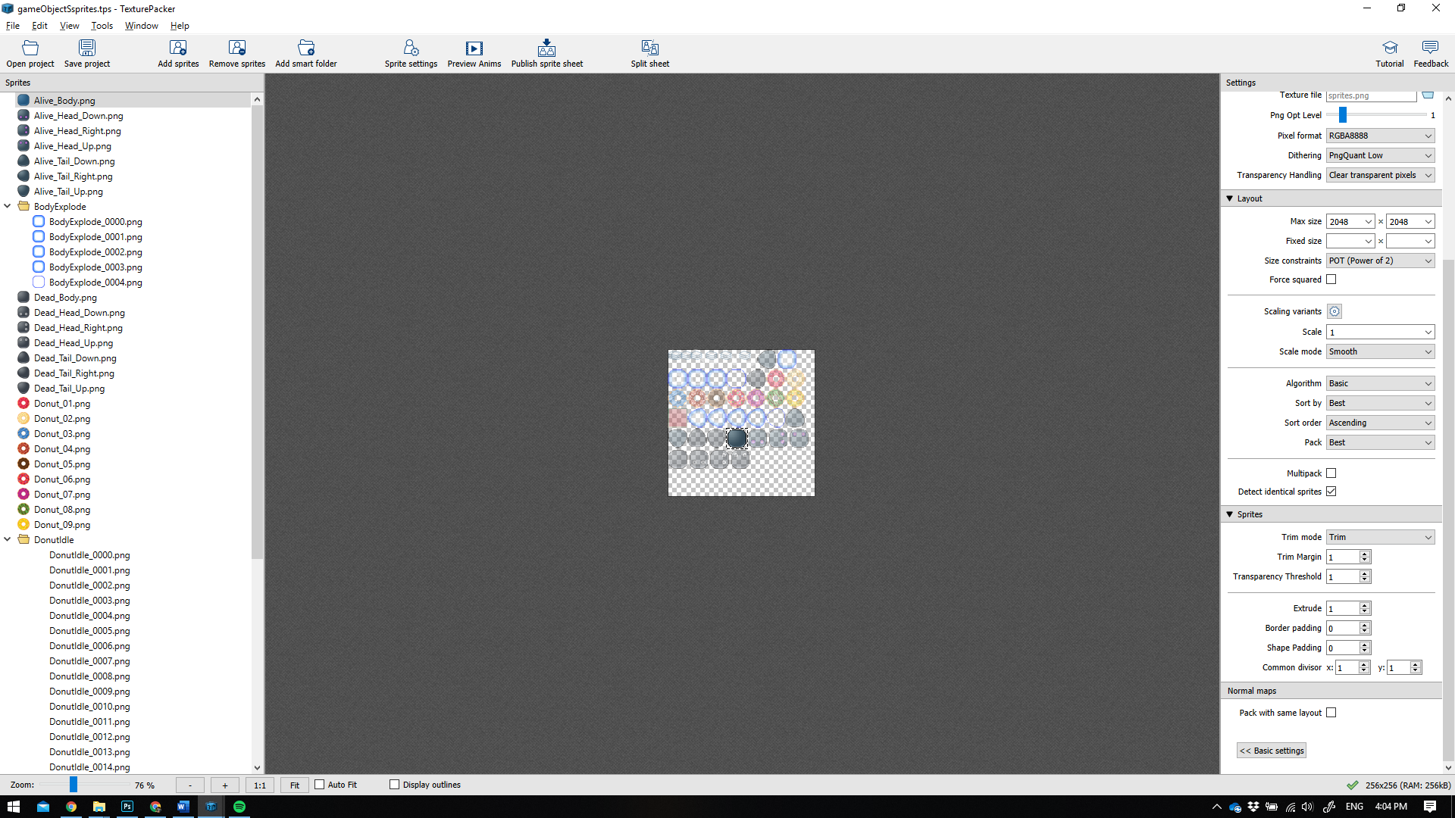

* When everything is ready press the Publish Sprite Sheet button, a popup would appear and notify you that the export process has finished. It’s time to send the exported JSON and PNG to your programmer or commit to GitHub.

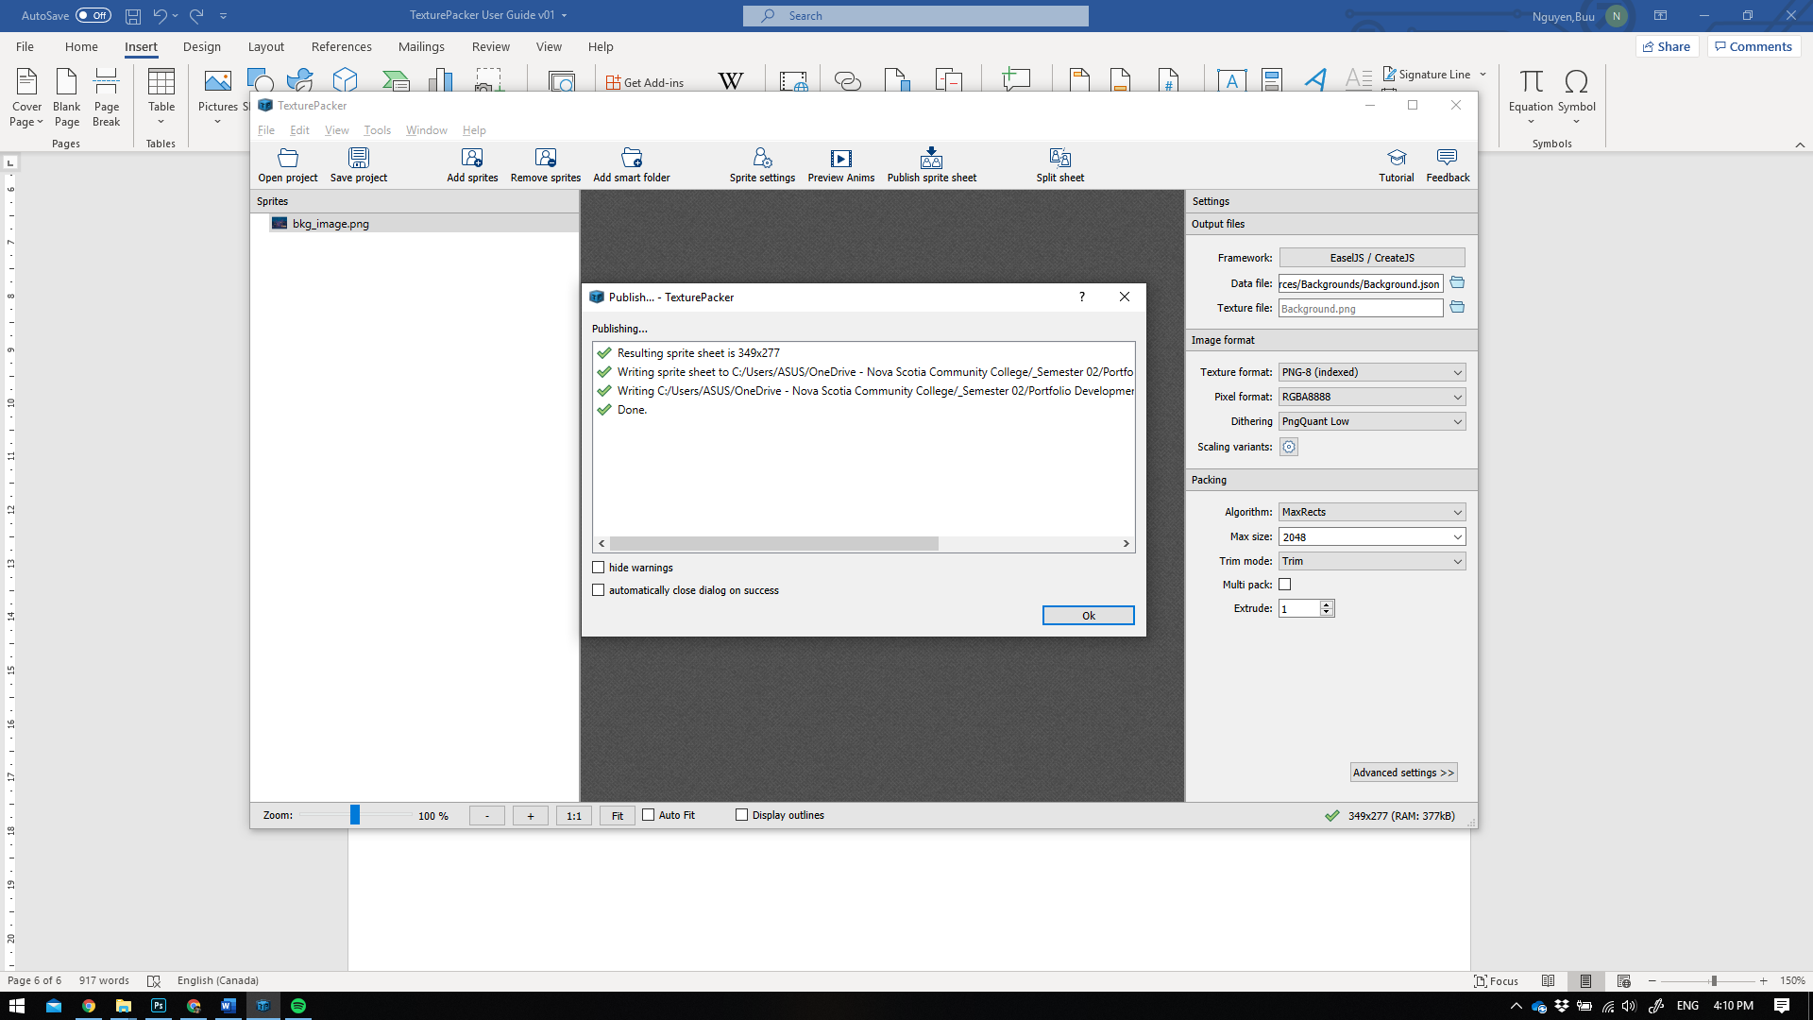

## Creating dynamic assets

Dynamic assets are artwork that has animation, like character with walking, jumping animation.

Normally I would like to put all sprites of all artworks into one big JSON file. However, due to the scope of this project, I would recommend you put them separate JSON files. This would help prevent potential bugs that could slow us down.

The process would be the same as creating static asset. In this guide, I will demonstrate how to create a character sprite that has 2 different animations.

In this example, I am going to use my bluebird character.

* I have two folders contains two different animation files exported from Photoshop using Render Video function

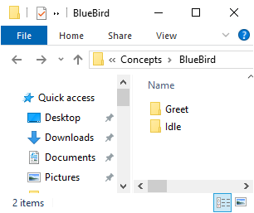

* Open TexturePacker and drag the parent BlueBird folder that holds the animations into it.

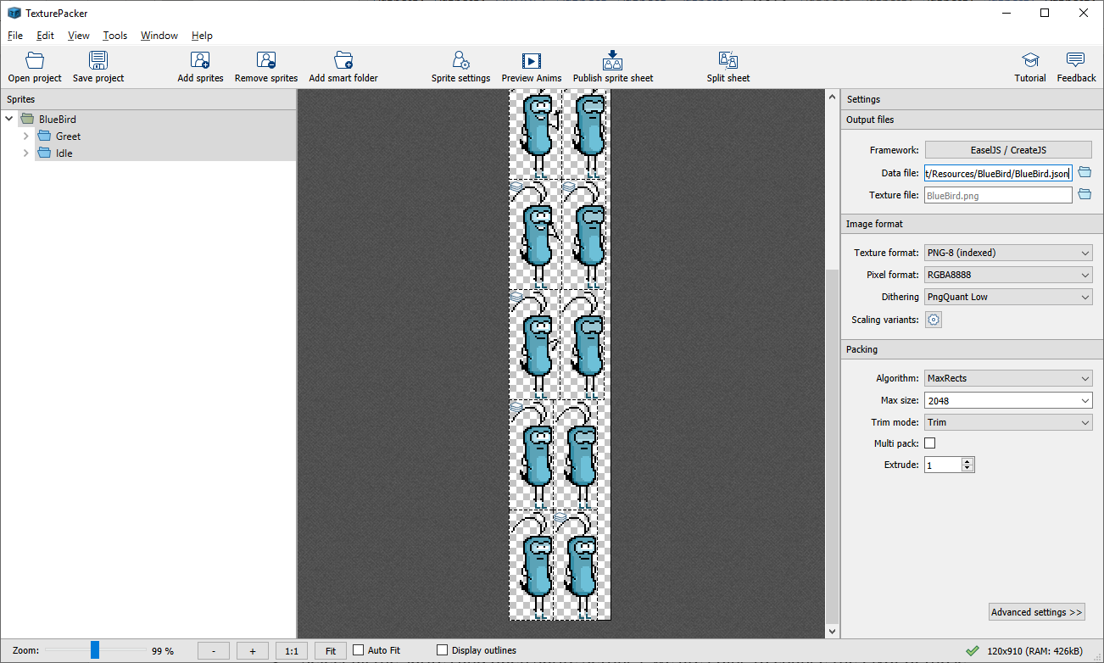

* Specify a new name and path for this sprite.
* Use the same settings described in Creating static assets section.
* Select all the sprites and open Sprite Settings, we are going to change the Pivot of those sprites a little bit different this time.

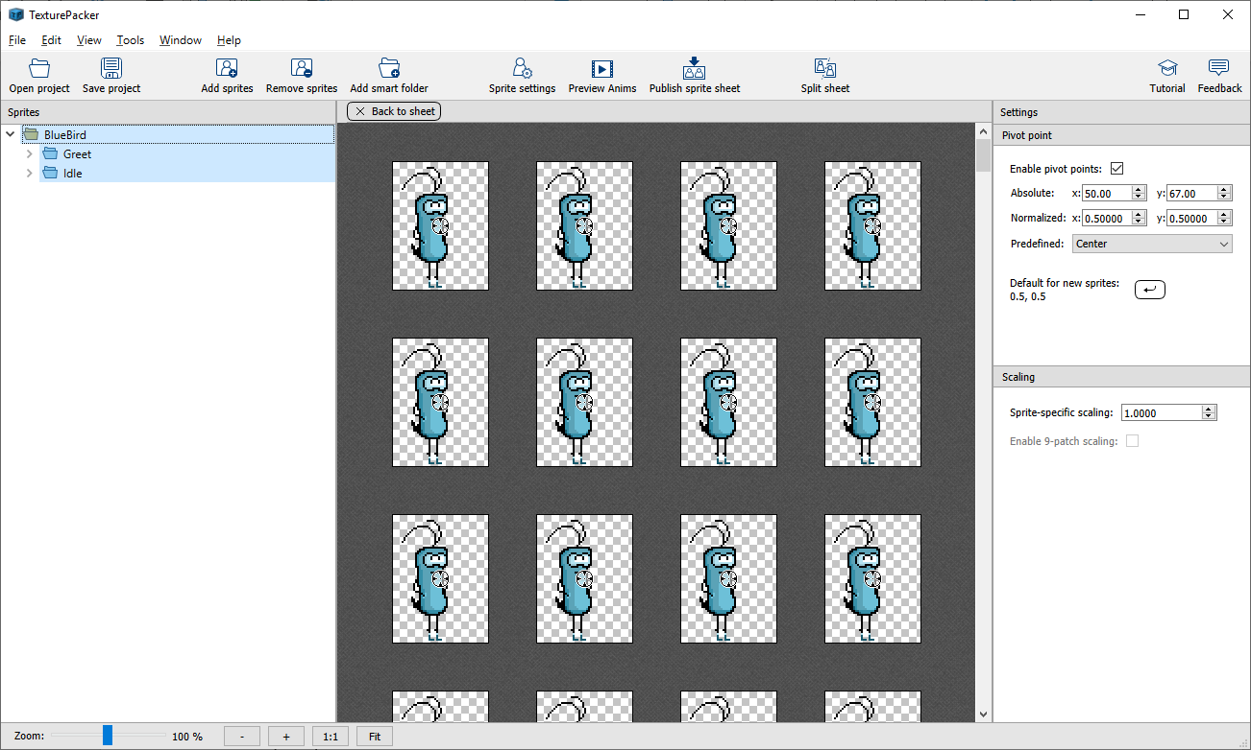

* Use Bottom Center for the Pivot Point

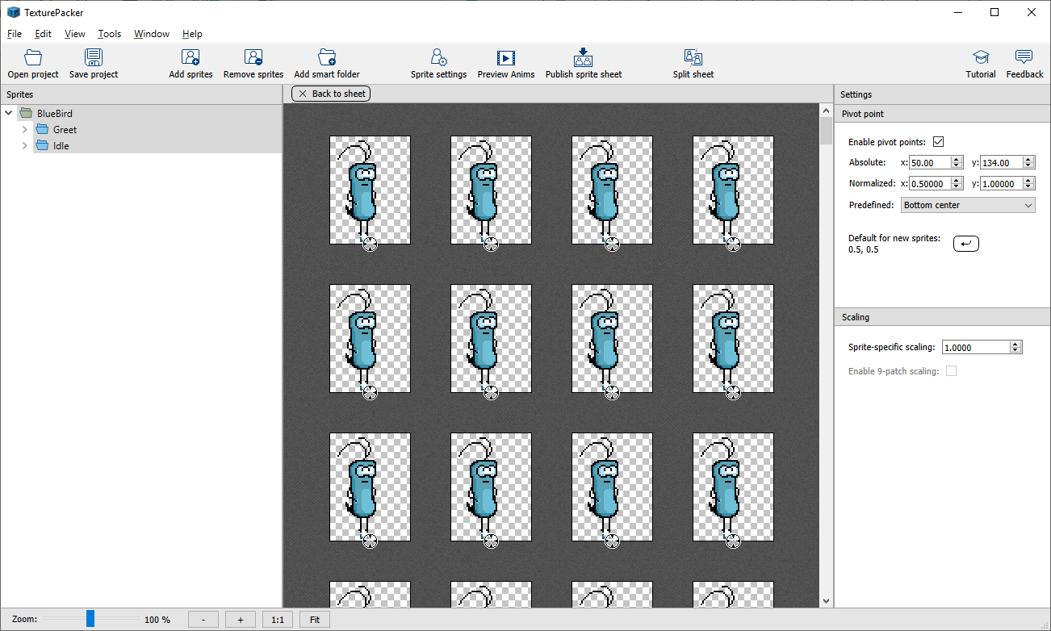

*Explanation*: This is an animated character that can be controlled by player. The feet are the most frequent things that collides with other objects during gameplay. Putting the pivot at the feet helps programmer a lot in coding. We could manually do it ourselves, but with the acknowledgement and help from artists would benefit all of us and make the work goes faster overall.

If you were unclear where you should set the pivot point of a certain sprite, just simply ask the programmer. If they are not available now and you need to finish your task anyways, set it to Top Left.

* You could hit Publish Sprite Sheet at this point.

## Summary

Things to remember before **publishing the sprite sheet**

1. Make sure all settings and pivot points are set correctly.
2. Uses different JSON file for each character, do not make an All-In-One file.
3. If anything is unclear, give your programmer a nudge.

# Creating Glyph assets aka. Graphic fonts for games (I will write this next time)